HONORS DISCRETE PRACTICE MULTIPLE CHOICE
CHAPTER 9: FIBONACCI AND RECURSIVE SEQUENCES
Pick the MOST ACCURATE Answer Choice
- Calculate the value of F₂₇ =
A) 196,418 B) 219,602 C) 439,204 D) 121,393

- Calculate the value of 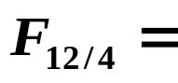
- 2 B) 3 C) 21 D) 48

- Calculate the value of 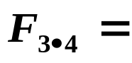
- 6 B) 9 C) 12 D) 144

- Calculate the value of 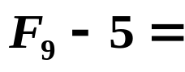
- 3 B) 4 C) 29 D) 50

- Calculate the value of 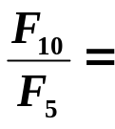
A) 5 B) 11 C) 18 D) 55

- Calculate the value of 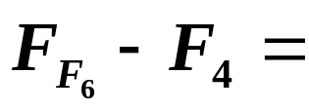
A) 4 B) 5 C) 18 D) 21

- Calculate the value of 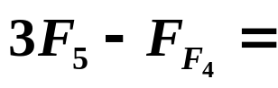
A) 3 B) 13 C) 9 D) 11

- Calculate the value of 4 F₁₁ - ₅ =
A) 32 B) 8 C) 24 D) 20

- Calculate the value of 2 F₃₊₄ =
A) 7 B) 10 C) 13 D) 26
- Which recursive rule best describes the sequence -5, -3, -1, 1, …
A) a_{n} = 2a_{n-1} -4 B) a_{n} = 3a_{n-1} - 8 C) a_{n} = a_{n-1} + 2 D) a_{n} = 2a_{n-1} – 3

- Which recursive rule best describes the sequence 3, 14, 36, 80, …
A) a_{n} = –2a_{n-1} B) a_{n} = a_{n-1} + 6 C) a_{n} = a_{n-1} + 11 D) a_{n} = 2a_{n-1} + 8
- Which recursive rule best describes the sequence 7, 23, 87, 343, …
A) a_{n} = a_{n-1} + 16 B) a_{n} = 4(a_{n-1}) - 5 C) a_{n} = 3(a_{n-1}) + 2 D) a_{n} = 2(a_{n-1}) + 9
- For a sequence with recursive rule a_{n} = 2(a_{n-1} - 1) and seed a₁ = 5, which of the following represents the 5th term of the sequence?
A) 8 B) 14 C) 26 D) 50

- For a sequence with recursive rule a_{n} = 4a_{n-1} + 7 and seed a₁ = -2, which of the following represents the a₄?
A) – 1 B) 3 C) 15 D) 19

- For a sequence with recursive rule a_{n} = 5 - 2a_{n-1} and seed a₁ = 3, which of the following represents the 4th term of the sequence?
A) 7 B) 23 C) – 9 D) 27

- Which of the following best describes the sequence: 18, 6, -6, -18, …
A) Geometric B) Arithmetic C) Neither

- Which of the following best describes the sequence: a_{n} = a_{n-1} ÷ 3
A) Geometric B) Arithmetic C) Neither

- Which of the following best describes the sequence: 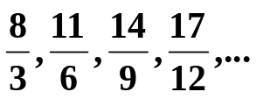
A) Geometric B) Arithmetic C) Neither

- Which of the following best describes the sequence: 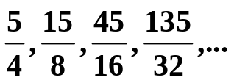
A) Geometric B) Arithmetic C) Neither
HONORS DISCRETE PRACTICE MULTIPLE CHOICE Chapter 9 SOLUTIONS

- A
- A
- D
- C
- B
- C
- C
- A
- D

- C
- D
- B
- D
- D
- C
- B
- A
- C
- A

